Code Review

Program Being Reviewed: Newlin

Reviewer: St4

Date Reviewed: 11/12/2018

Test Plan:
- Run program in online GDB
- Test inputs
- Review Code
- Write review

Static Analysis:

Vulnerabilities:
Overall the code looks pretty locked down. I can’t think of a way someone could exploit it. But if they did, I could see them using argv[1] to their advantage. You have placed no limit on the size of this argument or what can go in it unlike for the directory names. If an attacker was able to hijack the control flow of your program, they would have access to anything they wanted that they placed in argv[1]. (-5)
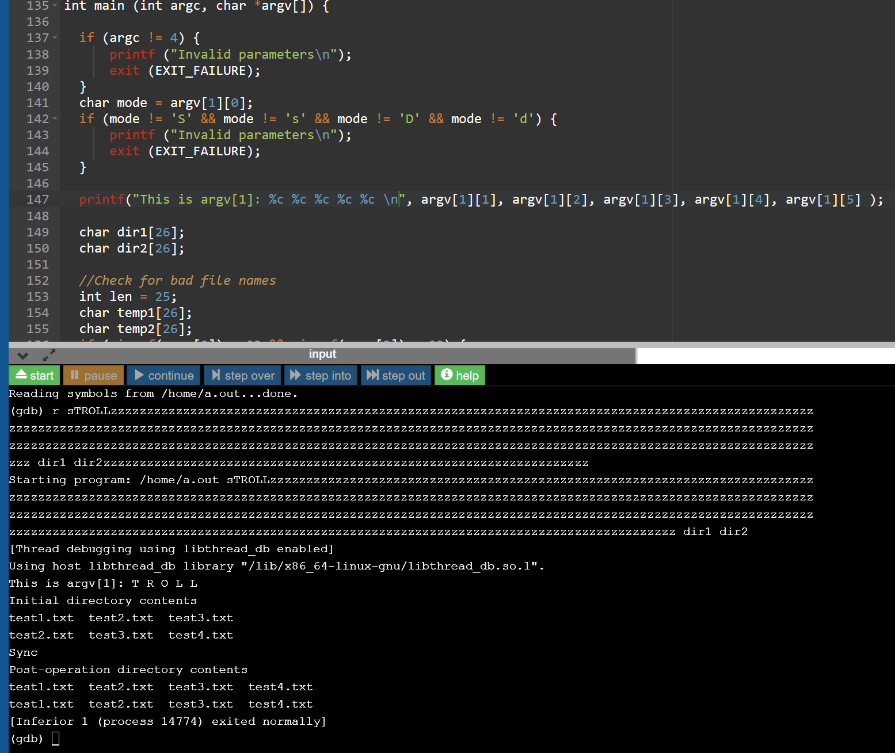

Test Results:

Self and Peer Review Rubric (70 points):
- Does the code run and compile (10)?
Yes the code does run and compile. (10/10)
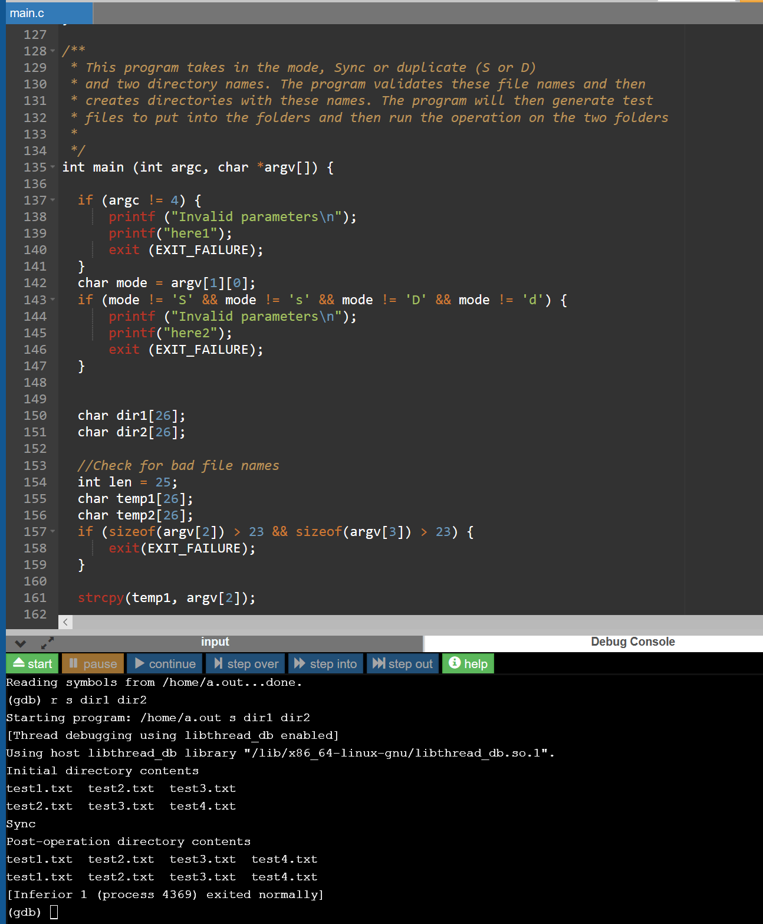

- Does the program functionally
  - Sync (30)
Yes sync works as written. The files are compared by filename to determine if they are the same. (30/30)
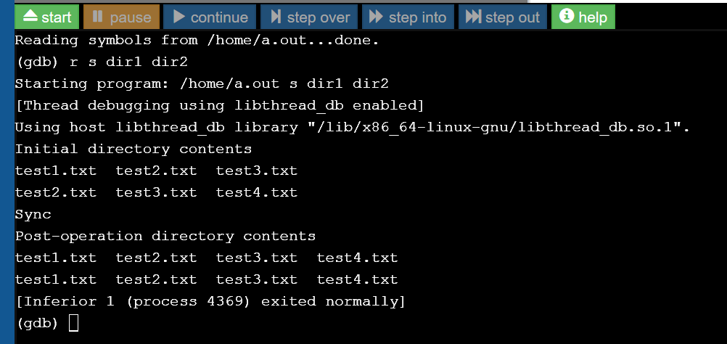
  - De-duplicate (30)?
Yes the function deduplicates the files of one folder compared to another.
